













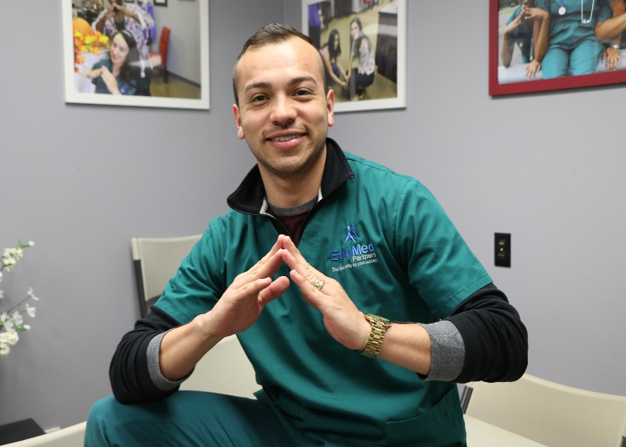
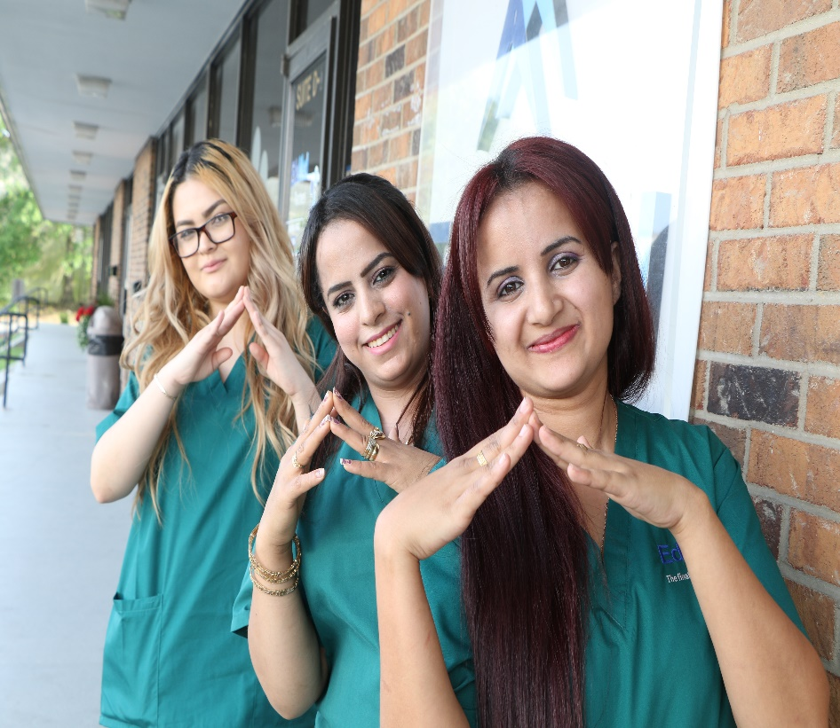
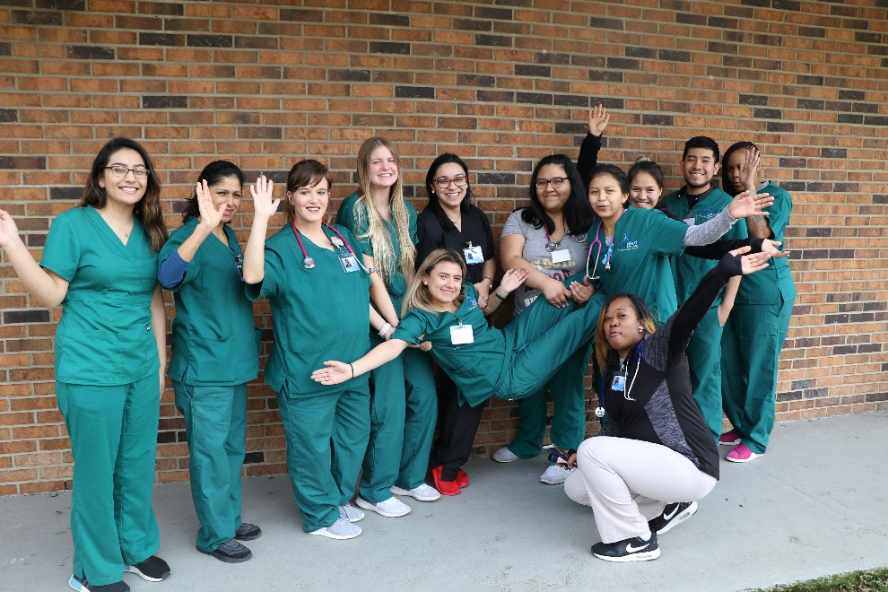
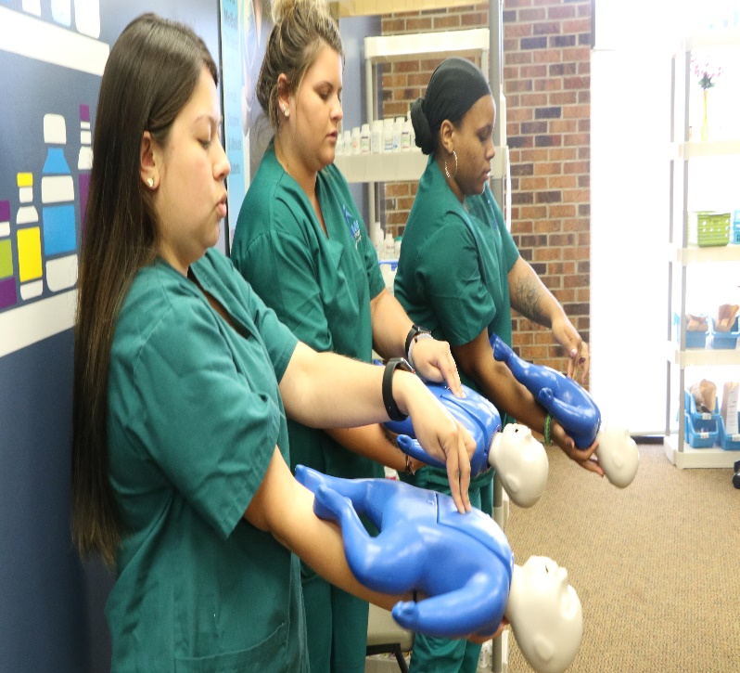

2026

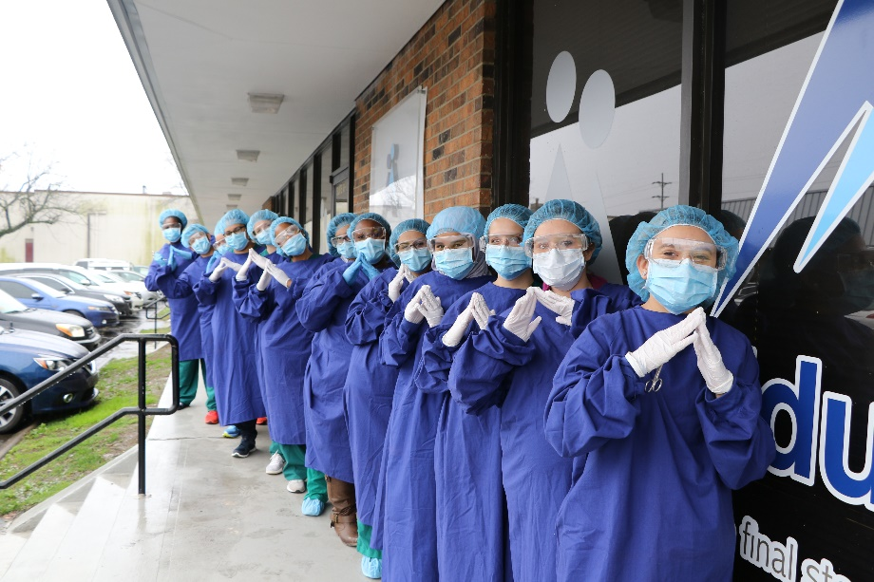

Publication Date: 12/2/2026, Edition 1

www.edumed-partners.com

TABLE OF CONTENTS

SECTION NAME PAGE NUMBER SECTION NAME PAGE NUMBER
Academic Calendar 22  Admissions Policies 5  Advisement and Tutoring 14  Alcohol and Drug Policy 14  Appeal Process 12-13  Attendance Policy 9  Authorization Statement 3  Break Room 14  Business Hours 4  Cancellation and Withdrawal 5-6  Career Placement Assistance 15  Class Hours 4  Clinical Externship Hours 10  Cost and Tuition 16  Course Descriptions 18-21  Description of Facility and Equipment 4  Dismissal from Externship Site 12  Dismissal from School 12  Equal Opportunity Statement 4  Externship Repeat Policy 11  Facility Address and Telephone 3  Faculty Requirements 4  Faculty and Staff 23  General Information 14  Grade Appeals 13  Graduation Requirements 10  Hours of Operation 4  Incident Reporting 15  Inclement Weather Policy 14  Laboratory Settings 15  Late Enrollments 5-6  Leave of Absence 6  Make-up Work Policy 10  Mission Statement 3  Other Appeals 13 | Our History and Purpose 3  Owners and Officers 3  Parking 14  Programs of Study 17-18  Progress Reports 10  Qualitative Measure 8  Quantitative Measure 8  Re-Admission Policy 10  Refund Policy 6-7  Repeat Course Policy 11  Repeat Fees 11  Retention of Records 15  Satisfactory Academic Progress Policy 7  Satisfactory Progress and Grading Scale 10  Smoking 14  Standards of Conduct 12  Student Advisement and Tutoring 14  Student Appeal Process 12-13  Student Grievance Policy 13-14  Student/ Instructor Ratio 14  Students with Disabilities 5  Transfer of Credits 11  Transfer of Students Between Programs 12  Visitors to the Campus 14

Our History and Purpose:

EduMed Partners LLC is a group of professionals who possess the experience and knowledge to provide the best training in our market area. A group of educators that believe teaching through real
experience and hands-on training is the most eﬀective way of learning for a successful entrance into the work force. A caring and talented group that understand the needs of the markets we serve.

Mission Statement:

- To provide students with a dynamic educational experience which focuses on instruction through active learning techniques.

- To equip students with elevated levels of technical and communication skills in order to succeed
in their chosen career.

- To aid students in obtaining entry-level positions within the community.

- Furthermore, to provide our market area with educated and highly skilled professionals.

Authorization Statement:

EduMed-Partners, LLC is authorized by the Tennessee Higher Education Commission. This authorization must be renewed each year and is based on an evaluation by minimum standards concerning provision of education, ethical business practices, health and safety, and ﬁscal responsibility.

EduMed Partners, LLC is Accredited by the Commission on Occupation Education.

Owners and Oﬃcers



Kleber Molina, MD
President/CEO

Sandra Overton, MT, MBA
Vice President/CFO
FACILITY ADRESS
TELEPHONE:

907 Rivergate Parkway
Suite D2
Goodlettsvile, TN 37072

Facility Address:
615-680-4106

907wgtfrrrrrrrrrrrrrrrrrmn deeF615-369-8630

Description of Facility and Equipment

EduMed-Partners is located at 907 Rivergate Parkway, Suite D2, Goodlettsville, TN, 37072. The school consists of 3,800 square feet with a reception area, resource area, 1 student break room,
1 administrative oﬃce, 1 instructor workroom, 1 storage/ﬁle room, 1 laboratories, and 1 classrooms. Male and Female restrooms are located in the main hallway. Both restrooms are handicap accessible.

EduMed Partners, LLC has the equipment and various supplies to meet the needs of each program.

Clinical Medical Assisting (CMA) has exam tables, IV stands, otoscopes, Scales, various surgical equipment necessary to ﬁt the need for stitching. Also, blood pressure equipment, mannequins, Urinalysis Analyzer, Microscopes, injection pads, fake arms to learn phlebotomy and various other equipment.

Phlebotomy also has a Centrifuge, various waived serology kits, fake arms to practice venipunctures as well as a wide variety of phlebotomy supplies.

HOURS OF OPERATION:

The hours of operation for EduMed-Partners, LLC are as followed:

CLASS HOURS MAY BE SCHEDULED:

MONDAY-THURSDAY......................................................8:00 a.m. – 10:30 p.m.

BUSINESS HOURS:

MONDAY-THURSDAY.............................................. 8:00 a.m. – 5:00 p.m. FRIDAY - SATURDAY................................................ 8:00 a.m. - 12:00 p.m.

Equal Opportunity Statement

In compliance with the Civil Rights Acts of 1964 and Title IV of the Education Amendments of 1972, and Section of 504 of the Rehabilitation Act of 1973, EduMed-Partners is an equal opportunity institution and is dedicated to non-discrimination. Qualiﬁed students, applicants, or employees will not be excluded from any course or activity because of race, color, religion, national origin, sex, age, disability, sexual orientation, qualiﬁed handicap, or marital status.

Faculty Requirements

Faculty must have at least 3 years work experience as a Medical Assistant to teach the MA and Phlebotomy Program.

Students with Disabilities

EduMed complies with the Americans with Disabilities Act of 1990 and is wheelchair accessible. If enrolled under training with a government agency, institution direct, and/or other entity, students must meet the admission requirements set out in the training agreement and/or applicable state licensing or certification requirements. EduMed is equipped with ramp access from the parking lot.

If you are interested in attending school, but are in need of reasonable accommodation, you should schedule an appointment with the Director. At this meeting, we will discuss the nature of the reported disability and its impact on learning. We will also discuss the process of receiving reasonable accommodations, and the type of accommodations available.

Please bring copies of current documentation of a disability to the meeting. Documentation must be provided by a medical expert within the last three years and include:
- A diagnosis of the disability.
- How the diagnosis was determined (what tests were given and the results); and
- A clinical summary, which includes an assessment of how the disability will impact the individual in a college environment and what accommodations are recommended.
Upon completion of the initial meeting, a formal request for accommodation must be submitted in writing to the school. The initial meeting, formal request, and response from the school must take place prior to the pre-enrollment process.

NOTE: One must be able to benefit with reasonable accommodations.

Admissions Policies

- Applicant must pass an Admission Assessment prior to beginning classes.
- An applicant must be a high school graduate or have a recognized equivalent diploma (GED) or have been home schooled according to State regulations.
- An applicant must participate in an interview with an admission representative
- Registration fee must be paid prior to admission for Cash Pay Students
- $700.00 must be paid prior to sitting in class for Cash Pay Students.

Late Enrollments
Student may enroll up to 2 days after the start date. All admissions criteria must be fulﬁlled in order to enroll. Student must arrange a time with the instructor to review and submit any work missed prior to enrollment by the end of the ﬁrst week.
Cancellation and Withdrawal
In accordance with the Tennessee Higher Education Commission (THEC) EduMed Partners, LLC utilizes enrollment agreements and maintains a cancellation/refund policy for money paid by student and other suppliers of tuition.

Oﬃcial withdrawal can be made in person or in writing to the Director of Education at the address of

- The Director of Education will complete a withdrawal form and distribute to the appropriate oﬃcials.
- Refunds and return of funds calculations are completed.
- Refunds, if applicable, are made to the appropriate accounts, ledger, agency, or student as
- applicable.
- A student who is absent ﬁve (5) consecutive scheduled class days will be automatically withdrawn from the institution. The students Last Day of Attendance (LDA) will be used in calculation any monies to be refunded in accordance with the refund policy.
- EduMed Partners, LLC will refund within 45 days, all monies paid by an applicant who is rejected for enrollment, or who enrolls in a program that EduMed Partners, LLC cancels, or who cancels their enrollment agreement within three business days of signing the agreement, minus the administrative fee of $100.00.

LEAVE OF ABSENCE POLICY

EduMed Partners is allowed to grant multiple leaves of absence provided that the student provides a request stating the reason for each leave, and the total number of days for all of the leaves cannot exceed ninety (90) school days in a 10.5-month period. The following applies:
- A written request should be made as far as is possible.
- If circumstances present the student from applying prior to the start of an LOA (e.g., injury in a car accident) The reason for the decision to grant an LOA, despite the failure of the student to apply in advance will be documented in the student’s file and the request will be obtained at a later date.
- All leaves of absence cannot exceed ninety (90) school days.

Students will be advised of the consequences of failure to return from a leave of absence. Failure to return by the approved time may have a negative effect on repayment of the student’s loans, including the depletion of some or all of the student’s grace period.

- If the student has not returned to school at the expiration of the leave of absence, the student will be withdrawn from the program and the withdrawal state will be the date the student began the leave of absence.
- Any student who has been on a leave of absence or withdrawal may reapply for Financial Aid Program upon re-entering the college.
- Any student who fails a class or takes a leave of absence are warned that their schedules may be interrupted which will cause their date of completion to be extended.

REFUND POLICY:

- A full refund will be made to any student or supplier of tuition and other expenses of a student where EduMed cancels classes. For any student who cancels enrollment on or before the ﬁrst day of classes or fails to begin classes. The sum shall be equal to sum of all amounts paid or to be paid by or on behalf of the student for the period of enrollment, less an administrative fee of $100. These refunds will be made within 45 days of notice from the student or no show to classes.
- Refunds will be made without penalty for any student who enrolls prior to visiting EduMed and then decides to withdraw within three days following orientation or a tour of facilities and inspection of equipment.
- Refunds will be based on scheduled clock hours of class attendance through the last date of attendance per quarter.
- The eﬀective date of termination for refund purposes will be the last day of attendance. If the student voluntarily withdraws it is the date of written notice by the student.
- Refunds will be made within 45 days of withdrawal.
- If a student withdraws after classes begin EduMed Partners, LLC will retain $100 administrative fee and the minimum refund of the remaining tuition and fees will be refunded as described below:
- During the ﬁrst 10% of the period of ﬁnancial obligation, the institution
- shall refund at least 90% of the tuition.
- After the ﬁrst 10% of the period of ﬁnancial obligation and until the end
- of the ﬁrst 25% of the period of obligation, the institution shall refund at
- least 50% of the tuition.
- After the ﬁrst 25% of the period of ﬁnancial obligation and until the end
- of the ﬁrst 50% of the period of obligation, the institution shall refund at
- least 25% of the tuition; and,
- After the ﬁrst 50% of the period of ﬁnancial obligation, the institution
- may retain all the tuition.
- Refunds, when due, are made without requiring a request from the student.
- All refunds will be based on the last day of attendance as described below:
  - The date of an expulsion notice if the student is expelled
  - The date the institution received a written notice including a signed notice of withdrawal form.
  - A withdrawal form from the student
  - When no written notice of the withdraw given
  - Or failure to return from leave.
- The period of enrollment at EduMed Partners, LLC is not to exceed 33 weeks in one program.

EduMed Partners Satisfactory Academic Progress Policy
Satisfactory Academic Progress (SAP) standards are published and are reasonably applied for measuring whether an otherwise eligible student is making SAP in his/her educational Program. In order to maintain eligibility for the program, students must make adequate academic progress toward completion of his/her program.

EduMed’s Medical Assistant Program: 600 Hours Total / 31 Weeks

QUANTITATIVE MEASURE

To be considered making SAP, Students are required to attend a minimum of 75% of his/her educational program in no longer than 100% of the published length of the program as measured in clock hours and determined by the program. Evaluations are conducted periodically to determine if students have met the minimum requirements and are based on the cumulative attendance percentage as of the last day of the evaluation period.

At the end of each evaluation period, the school determines if students have maintained at least 75% cumulative attendance since the beginning of the course. This indicates that, given the same attendance rate, the student will complete within the time frame allowed.

Full-time students are scheduled to attend (20) clock hours weekly.

QUALITATIVE MEASURE

The qualitative measure, used to determine SAP, is based on grades. Students must maintain a cumulative grade point average of at least 75% at the end of each evaluation period. (A school may have an overall cumulative GPA AND a semester GPA requirement, but the Cumulative GPA must be used for SAP).

Students receive a numerical grade as indicated on the chart below and is based on the end-of-semester evaluations. Students who receive a grade of 74% or below will be required to repeat that course.

96 -100 A

85 - 95 B

75 – 84 C

74 and below F

Attendance Policy:

All attendance will be recorded by the minute. Students will be required to complete 75% of the scheduled contact hours and 100% of clinical externship hours. Students who miss 25% or more of the scheduled didactic or laboratory courses may be withdrawn from the class. A grade of “W” may be issued as the ﬁnal grade. A student may appeal if the absence was due to extenuating circumstances, for example, serious illness, military duty, death in the family, court, or jury duty.
Each student will receive a “Notice of Unsatisfactory Attendance” upon missing 10% of the class.

10% and 25% missed attendance is deﬁned by the following:

Contact Hours

40
80
10% missed (in hours)

4 hours
8 hours
25% missed (in hours)

10 hours 20 hours

Re-Admission Policy:
If a student is withdrawn or suspended, he or she may apply for re-entry for the next available start date. All students who re-enter must meet with a representative from the Education Department before starting classes and be up to date on payments.

Clinical Externship Hours:
100% of all externship hours must be completed and a grade of 75% or higher to pass clinical externship and graduate from the respected program.
Students will be allowed to miss two (2) days of externship. If the student will be absent, the following steps MUST be followed in order to avoid dismissal from the externship site:
- Student must notify the On-site Supervisor appointed by EduMed-Partners, LLC at least 30 minutes prior to designated start time.
- Students must notify the Externship Coordinator at least 30 minutes prior to the designated start time. If the externship coordinator is unavailable, a voicemail which states the student’s name, clinical site, date, time, and return phone number where the student can be reached.

Graduation Requirements:
All required courses in the prospective program MUST be completed and a grade of 75% or higher obtained. Also, all requirements of the Clinical Externship must be satisﬁed as well as the student must be in good standing with the Business Oﬃce and all Fees paid.

Satisfactory Progress and Grading Scale:
A ﬁnal grade of 75% or higher is required for each course, including externship, within the respected program of study to graduate from the program. 100B

Students who earn a grade of 74% or below ( F ) will be required to repeat the course. To graduate, a student must pass every course in the respected program with a ﬁnal grade of 75% or above.

Progress Reports:
Progress reports will reﬂect progress after two weeks of a four-week course and after (7) seven days of a 2-week course. Each student can obtain their progress report at any time in the Orbund software system. The progress report will reﬂect the numeric and letter grade to that date.

Make-up Work Policy:
- Classwork- Missed classwork may be accepted 1 day after return with 15% deducted. Assignments that are not submitted 1 day after return will remain a zero.
- Homework-Missed homework will be accepted 1 day after return with 15% deducted.
- Pop Quiz- Missed “Pop Quizzes” may receive a zero.
- Announced Quiz and Tests- Student may schedule a make-up time with the instructor or
Program Director within 2 days of returning to school. A diﬀerent version of the test may be
issued.
- Laboratory Assignments- Students will be required to make up all laboratory assignments
within one week of returning to school. Laboratory hours will be at the discretion of the
course instructor. Makeup Laboratory may be scheduled between Monday and Saturday and
during the hours of 8am and 10:30pm.
- Final Exam – Missed Final Exams without extenuating circumstances are to be scheduled by
the student within three days of returning to school.

Repeat Course Policy:
No student will be allowed to attempt a single course more than three (3) times. If the student withdraws from the course, a “W” will be issued. A grade of “W” is considered a course attempt. If a student does not pass a single course (excluding externship) after three (3) attempts, the student will be dismissed from the program of study and will not be allowed to apply for re-entry.

Externship Repeat Policy (MA):
A student may only have two (2) attempts at successfully completing the externship course. If the student is not successful (meeting the required externship hours and a grade of 75% or higher) after two attempts; the student will be dismissed from the program of study. The student may not be allowed to apply for re-entry.

Repeat Fees:

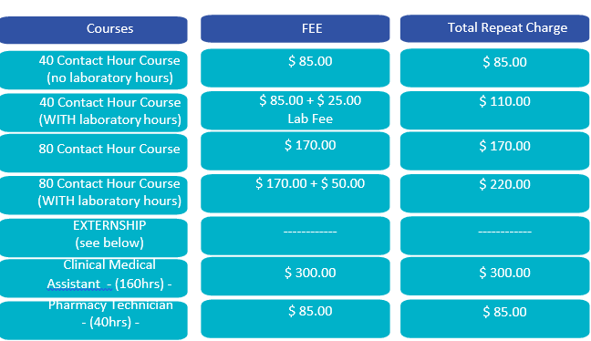
The repeat fees for all programs are as followed:

ourses
) –

Transfer of Credits:
EduMed Partners, LLC is a special-purpose institution. That purpose is to provide highly skilled entry-level employees to the markets we serve. This purpose does not include preparing students for further college study. Students should be aware that the transfer of credit/contact hours is always the responsibility of the receiving institution. Whether or not credits transfer is solely up to the receiving institution. Any student interested in transferring credit hours should check with the receiving institution directly to determine to what extent, if any, credit/contact hours can be transferred.

It is highly recommended, and you are advised to make certain that you know the transfer of credit policy of this institution and of any other educational institutions you may in the future want to transfer the credits earned at this institution before you execute an enrollment contract or agreement.
If a student wishes to transfer credits from another institution to EduMed Partners, LLC, a written letter requesting transfer of credits, Oﬃcial-Sealed Transcripts, and course descriptions from the transferring institution must be submitted the Director of Education. EduMed Partners, LLC only accepts credits from an accredited school by an agency recognized by the U.S. Department of Education.

Transfer of Students Between Programs
Students may transfer credits within programs with the approval of the Director of Education.

Standards of Conduct
- Students are to be respectful to classmates, administration, faculty members of the EduMed-Partners.
- Students must be respectful to Mentors and/or Supervisors of clinical externship sites¬
- Cursing or Inappropriate Language will not be tolerated.
- Physical Altercations and weapons will not be tolerated. Students may be dismissed from the program immediately.
- Cheating/ Plagiarism will not be tolerated. Any student who is caught with cheating / Plagiarism will be given a grade of “0” for the assignment. Students may be suspended or dismissed from the institute.
- Cell phones must be oﬀ during class.
- Follow Dress Code
- Willful Destruction of School Property

Dismissal from School
All students are expected to be professional and conduct themselves as responsible adults, attend class regularly, and to maintain a satisfactory level of academic achievement. EduMed-Partners, LLC reserves the right to dismiss or suspend any student who:
- Exhibits conduct found by the administration to be detrimental to the following students, other individuals. The community, or the School, as outlined in the “Conduct” section of this catalog.
- Fails to maintain satisfactory academic progress.
- Fails to meet attendance policies.
- Does not meet ﬁnancial obligations to the school.

Dismissal from Externship Site (MA):
All Clinical Externship sites reserve the right to not accept or dismiss a student if violations to internal policies are not followed by the student. Externship sites have agreed to help you complete your hours and training required for your graduation.
Students may be dismissed from the clinical externship site for the following:
- Excessive Absenteeism
- Inappropriate conduct (dress code, professionalism, inappropriate use of cell phones computer usage)
- Tardiness
- Lack of Motivation
- Lack of Safety (for patients or procedures)
- Late or No Submission of Weekly Timesheets, Evaluations, or Activity Logs.
If a student wishes to apply for Re-Admission after dismissal, please refer to the Re-Admission Policy.

Student Appeal Process
A student may appeal a campus' decision such as a grade, attendance, suspension, or dismissal. Classroom concerns or issues should be directed to the class instructor during non-class hours. If issues or concerns are not handled at the instructor level, the student should go to the Program.

Director. If there is no Program Director appointed, the student should go to the Director of Education.

Grade Appeals
- A student may appeal a ﬁnal course grade in writing within one week of the class ending in which the grade was received.
- Documentation, returned assignments, test, quizzes, homework, and any other supporting information must be submitted WITH the original appeal.
- The Director of Education will review the appeal and respond within 72 hours of receipt of the
- appeal.
- The student acknowledges that a grade appeal may result in a higher or lower grade if documentation supporting the correction of a mathematical error.

Other Appeals
- All other appeals must be submitted in writing to the Director of Education.
- Each appeal must be dated and signed by the progression.
- Each appeal must include an explanation of the issue at hand.
- The Director of Education will respond to all appeals within 72 hours of receipt of the appeal.
- If the Director of Education is not available, the Campus Director shall receive the appeal. The Campus Director will have 72 hours to provide a decision.
- Documentation of the appeal will be placed in the students’ permanent ﬁle.

Student Grievance Policy:
EduMed-Partners would like to solve any reasonable complaints within our institution with both parties reaching a satisfactory agreement. We ask that you follow the chain of command as listed below:

FIRST: Any grievance should initially be discussed with the instructor of the course or Program
Director.

SECOND: If there is no resolution within 5 days at the instructor level, the grievance should then be reported to:

Sandra Overton Sandra Overton, CFO EduMed-Partners, LLC 907 Rivergate Parkway, D2 Goodlettsville, TN 37072
Telephone: 615-528-5444

phone: 615-528-5444
THIRD: If there is no resolution within 5 days of contracting the CFO, students are to report the grievance to the Campus Director:

Dr. Kleber Molina, CEO EduMed-Partners, LLC 907 Rivergate Parkway, D2 Goodlettsville, TN 37072
Telephone: 615-528-5443
ay, D2 Goodlettsville, TN

FOURTH: If the complaint is not settled at CEO level, students may then contact the Tennessee Higher Education Commission, Nashville, TN. 37243-0830, phone (615) 741-5293. Any person claiming damage or loss as a result of any act or practice by this institution that may be a violation of the Title 49, Chapter 7, Part 20 or Rule Chapter 1540-01-02 may file a complaint with the Tennessee Higher Education Commission, Division of Postsecondary State Authorization after exhausting the grievance process at the institution.

Alcohol and Drug Policy
Alcohol or any substance used in any way other than prescribed by a medical professional is prohibited on campus and during the externship.
Drug screens may be mandatory upon reasonable suspicion which will be determined by the Campus Director. If the results return a positive ﬁnding, the student will be suspended or expelled at the discretion of the institution.

Student Advisement and Tutoring
Advising and Tutoring is available upon request. All instructors are available to tutor as well as the Program Director. All requests for tutoring should be presented to the Director of Education or Program Director.

Inclement Weather Policy
EduMed Partners, LLC will announce school closing due to weather or unforeseen circumstances on WSMV Channel 4 News, FOX 17 and EduMed Facebook. Any inquiries in regard to closing may call or text to (615) 680-4106.
Any class time missed due to weather or unforeseen conditions will be rescheduled. Make-up classes may be rescheduled M-F from 8:00a.m.- 10:30p.m. If at that time a student is absent for the scheduled make-up hours, the attendance shall reﬂect “absent” for the scheduled time.

Visitors to the Campus
All school visitors must see the Front Oﬃce Receptionist. Visitors may only be allowed on the campus or in the classrooms with permission by the Director of Education.
*Please arrange childcare prior to class. Children will not be allowed to wait on campus in order for the student to attend class.

General Information
Break room
The student break room is available during regular business hours. EduMed-Partners asks all students to respect others while in the break room and refrain from any loud or distracting noises or activities.

Parking
Students may park within the complex between the 2 dumpsters only. To be courteous, we ask that students avoid parking directly in front of other tenant's front entrance. Handicap spaces are available for those in need.

Smoking
Smoking is permitted in designated area left of the main entrance. We ask all students and faculty to be courteous and dispose of cigarettes appropriately.

Classroom Student / Instructor Ratio
Student / Instructor ratio for lecture is 40:1. Laboratory Student / Instructor ratio is 20:1.

Laboratory Settings:

General Rules:
In order to maintain a safe and clean laboratory environment, the following rules must be followed in the laboratory setting:
- No food or drink
- Students may not apply makeup ( including lip balm) or lotion in the laboratory
- Maintain Dress Code Policy
- Students may not instill any eye drops or contact lenses within the laboratory area.

Accidental Dirty Needle Stick:
- Notify Instructor Immediately.
- Wash area with warm water and soap
- Bandage if needed
- Student's will be instructed to go to the school provider or nearest Emergency Room
- Upon return, the student must present a superbill or documentation from the facility that provided service.

Career Placement Assistance
Career Services will assist students with employment opportunities and resume preparation. EduMed-Partners, LLC does not guarantee or promise employment to graduates of any program of study.
EduMed prepares students for an entry-level position.

Incident Reporting
EduMed staﬀ and administration strive to provide each student and visitor with a safe welcoming environment. If during your enrollment at EduMed you have an accident or incident at any time see your instructor for help ﬁling out an incident form. This form is used to improve your experience and ensure accidents are kept at a minimum.

Retention of Records:
EduMed Partners, LLC will retain records and accounts of students for a period of seven years following course completion. These records will be made available to the student upon request and certiﬁcation.

Cost and Tuition: 2023-2024 Tuition and Costs
Tuition Fees Total
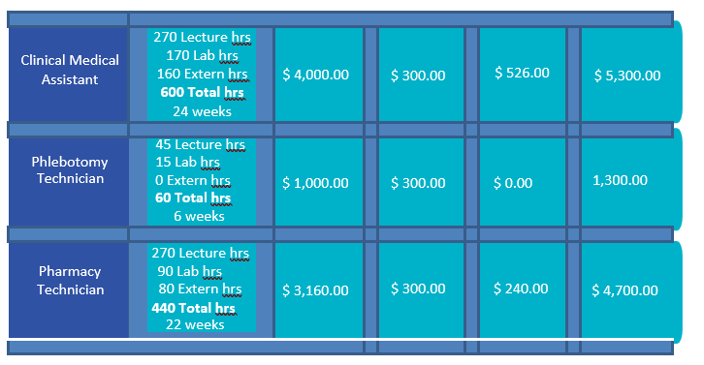

$6500 $1000 $7500

$1600 none $1600
1,600.00

Programs of Study:
Clinical Medical Assistant
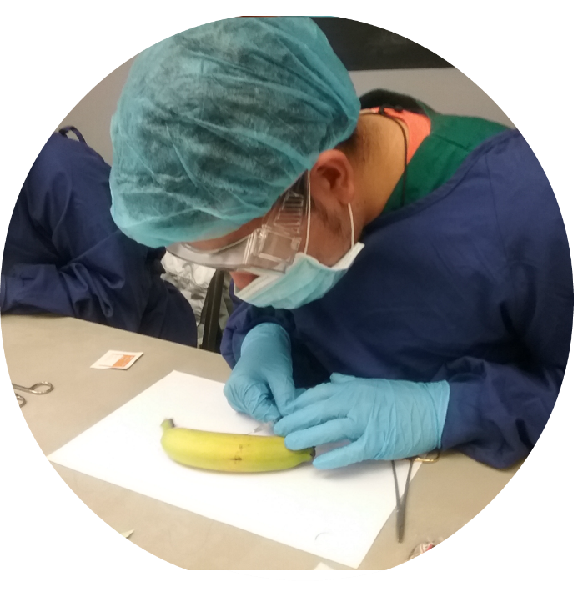
Course Length:( 7.0 Months /31 Weeks-excluding breaks)
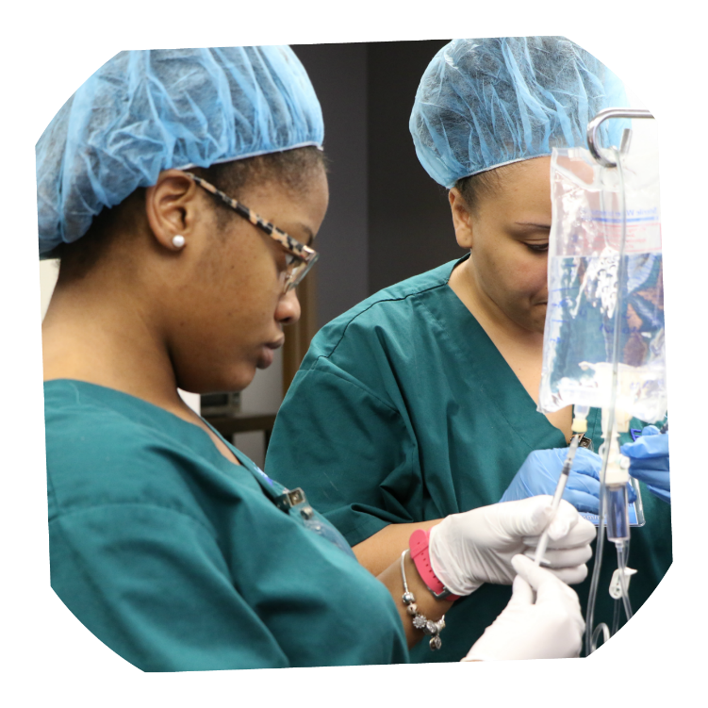
EduMed Partners, LLC Clinical Medical Assistant is a full-time program that provides students the knowledge base needed to enter the job market in the healthcare ﬁeld at entry-level positions. This training will give the graduate the ability to perform a variety of medical tasks allowing them to apply for positions in environments such as pediatrics, family practice, internal medicine, walk-in diagnostic clinics and many more. Training in this program will have an emphasis on assisting the physician by performing such duties as venipuncture, obtaining patient history, exam preparation, vital signs, administration of injections, ECG, specimen processing, set up for specialty procedures, casting, and assisting in minor surgical procedures.
The CMA program includes training on phlebotomy to the level each graduate is prepared for an entry level phlebotomist position as well as a CMA entry level position. Graduates of the MA program will earn a certiﬁcate for completed course work. After completing the medical assistant course, students will be eligible to set for certiﬁcation with such organizations as NHA for exams such as CCMA, CPT, and CET. CCMA is required by most facilities.
EduMed offers Medical Assistant classes monthly as seen in the Academic Calendar

COURSE | COURSE  CODE | LECTURE  HRS | LAB  HRS | EXTERN  HRS
- Intro to Health Careers | AHC100 | 30 | 10 |  | 0 | 40
- Anatomy Physiology I & Medical  Terminology | BIO101 | 40 | 0 |  | 0 | 40
- Anatomy Physiology II & Medical  Terminology | BIO102 | 40 | 0 |  | 0 | 40
- Vital Signs & Patient Prep | MAS100 | 20 | 20 |  | 0 | 40
- Phlebotomy | MAS101 | 20 | 20 |  | 0 | 40
- Electrography Techniques | MAS102 | 20 | 20 |  | 0 | 40
- Clinical Lab &Spec Processing | MAS103 | 20 | 20 |  | 0 | 40
- Medicine Administration | MAS104 | 20 | 20 |  | 0 | 40
- Electronic Medical Record &  Front Oﬃce Skills | MAS105 | 40 | 40 |  | 0 | 80
- Pharmacology & Calculation | MAT100 | 20 | 20 | 0 |  | 40
- Clinical Medical Assistant Clinical  Externship | EXT102 | 0 | 0 | 160 |  | 160
TOTAL |  | 270 | 170 | 160 |  | 600

Phlebotomy Technician
Program Length: ( 60 Hours-excluding breaks )
EduMed Partners, LLC Phlebotomy Technician program is a part-time program and provides students the knowledge base needed to enter the job market in the healthcare ﬁeld at entry-level positions. This training will give the graduate the ability to perform a variety of tasks. Among these tasks are: a collection of blood and body ﬂuids, record keeping, and verifying patient information. Phlebotomy Technicians can also give patient instructions, pick up specimens, and collect drug screens. Students will also learn to operate centrifuge, clinical safety, patient rights, and basic anatomy
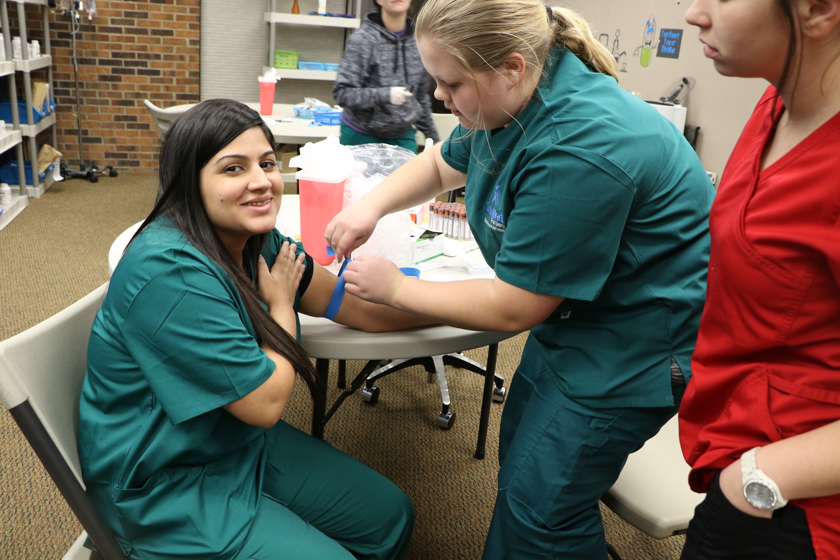
Graduates of the program will earn a certiﬁcate for completed coursework. After completing the phlebotomy technician course, students will be eligible to set for certiﬁcation with such organizations as NHA. Phlebotomists can ﬁnd employment in laboratories, physician oﬃces, hospitals, nursing homes, rehabilitation centers, walk-in clinics, mobile laboratories, American Red Cross, and home health agencies. CPT is required by most facilities.
EduMed offers Phlebotomy Technician classes periodically as seen in the Academic Calendar. Phlebotomy Technician

COURSE | COURSE  CODE | LECTURE  HRS | LAB  HRS | EXTERN  HRS | TOTAL  HRS
- Phlebotomy I | PHT101 | 15 | 0 | 0 | 15
- Phlebotomy II | PHT102 | 15 | 0 | 0 | 15
- Phlebotomy III & Certiﬁcation Prep | PHT103 | 15 | 0 | 0 | 15
- Phlebotomy Clinical Lab | PHT105 | 0 | 15 | 0 | 15
TOTAL |  | 45 | 15 | 0 | 60

Course Descriptions

BIO101 Anatomy Physiology I and Medical Terminology

Prerequisites: None
Contact Hours: 40 Lecture / 0 Laboratory

This course will focus on the basic study of structures and function of the human body and the Medi- cal Terminology as it relates to the systems including: cells, tissues, cardiovascular system, respiratory system, nervous system, special senses, and the lymphatic system.

BIO102 Anatomy Physiology II and Medical Terminology

Prerequisites: None
Contact Hours: 40 Lecture / 0 Laboratory This course will focus on the basic study of structures and function of the human body. This includes: The Integumentary system, Muscular system, Skeletal system, Urinary system, Digestive system, and Endocrine system. Medical terminology will be developed as it applies to these systems.

MAS103 Clinical Lab and Specimen Processing

Prerequisites: None
Contact Hours: 20 Lecture / 20 Laboratory

Students will learn clinical procedures routinely performed in a medical oﬃce setting. Students learn the medical laboratory including analysis of various types of specimens. Students will practice clinical procedures including venipuncture, handling blood samples, and demonstrating standard precautions. Students will learn the lab and minor surgical equipment utilized in the Physician Oﬃce.

EXT102 Clinical Medical Assistant Externship

Prerequisites: Students must complete three-fourths of the program to be eligible for an externship.
Contact Hours: 160 Externship Hours / 0 Lecture / 0 Laboratory

This course will provide the student with hands-on training in a clinical setting. The student will progress through competencies laid out in their clinical competency forms. This class will measure the student’s technical ability and aptitude, professional performance, ability to properly utilize medical terminology and abbreviations as well as clinical skills.

MAS102 Electrocardiography Techniques

Prerequisites: None
Contact Hours: 20 Lecture / 20 Laboratory

This course examines the anatomy and physiology of the cardiac and respiratory systems. This knowledge is related to the electrocardiograph procedures, involves the process of evaluating electrocardiogram tracings, and determining the presence of arrhythmia. Students will demonstrate the ability to successfully complete and properly mount and electrocardiogram; emphasis will be placed on recognizing a normal as well as an abnormal electrocardiography and classifying diseases of the heart.

MAS105 Electronic Medical Record and Front Oﬃce Skills

Prerequisites: None
Contact Hours: 40 Lecture / 40 Lab

This course will focus on maneuvering and documentation within the Electronic Medical Record as well as skills necessary for the front oﬃce. Students will enter patient data, set up appointments, document visits laboratory and diagnostic studies as well as scheduling. Also, the student will practice phone skills, calling back patients, calling in prescriptions, referrals, and become familiar with insurance needs of the oﬃce. They will understand precerts, simple coding, and the managing of a facility.

AHC100 Introduction to Health Careers

Prerequisites: None
Contact Hours: 30 Lecture / 10 Laboratory

This course introduces students to the health career environment. The course covers introduction to medical terminology, universal precautions, Bloodborne/Airborne Pathogens, HIV/AIDS awareness, knowledge of CDC guidelines, OSHA and infection control, and HIPAA and patient conﬁdentiality. The course includes Basic First Aid certiﬁcation, Adult, Child, and Infant CPR certiﬁcation, and AED training.

MAS103 Medicine Administration

Prerequisites: None
Contact Hours: 20 Lecture / 20 Laboratory

Students will learn the regulations and methods governing medicine administration and patient education. Students apply universal precautions, patient safety, and OSHA standards in handling, processing and administering medicine.

MAT100 Pharmacology and Calculations

Prerequisites: None
Contact Hours: 20 Lecture / 20 Laboratory

Students learn basic pharmacology including drug classiﬁcations, drug forms and sources. Students learn the importance of dosage calculations and apply the essentials of pharmacy mathematics through problem solving and critical thinking while using real world examples.

MAS101 Phlebotomy

Prerequisites: None
Contact Hours: 20 Lecture / 20 Laboratory

This course will develop the student’s skill in the performance of a variety of blood collection methods using proper techniques and universal precautions. Students will discuss and demonstrate vacuum collection devices, syringes, capillary skin puncture, butterﬂy needles and blood culture, and specimen collection on adults, children and infants. An emphasis on infection prevention, proper patient identiﬁcation, labeling of specimen and quality assurance, specimen handling, processing, and accessioning will be stressed. Topics include professionalism, ethics, and medical terminology.

PHT101 Phlebotomy I

Prerequisites: None
Contact Hours: 15 Lecture / 0 Laboratory

This course will develop the student’s skill in the performance of a variety of blood collection methods using proper techniques and universal precautions. Includes vacuum collection devices, syringes, capillary skin puncture, butterﬂy needles and blood culture, and specimen collection on adults, children and infants. Emphasis on infection prevention, proper patient identiﬁcation, labeling of specimen and quality assurance, specimen handling, processing, and accessioning.

PHT102 Phlebotomy II

Prerequisites: None
Contact Hours: 15 Lecture / 0 Laboratory

This course will continue to develop the student’s skill in the performance of a variety of blood collection methods using proper techniques and universal precautions. Emphasis will be given to special procedures used by a phlebotomist including times, drug monitoring, blood cultures, hormones, and more. Understanding of special protocols and techniques, using equipment and outcomes of procedures performed by phlebotomist.

PHT103 Phlebotomy III and Certiﬁcation Prep

Prerequisites: None
Contact Hours: 15 Lecture / 0 Laboratory

This course will continue to development the student’s skill in the performance of a variety of blood collection methods using proper techniques and universal precautions. This course will also take the student through each department in the laboratory. An emphasis on department testing, anticoagulants, and special procedures will be stressed.

PHT105 PHLEBOTOMY CLINICAL LAB

Prerequisites: BIO103, PHT101, PHT102, PHT104
Contact Hours: 0 Lecture / 15 Laboratory

This course will continue to develop the student’s skill in the performance of a variety of blood collection methods using proper techniques and universal precautions. This course will also take the student through each department in the laboratory. An emphasis on department testing, anticoagulants, and special procedures will be stressed.

MAS100 Vital Signs and Patient Preparation

Prerequisites: None
Contact Hours: 20 Lecture / 20 Laboratory

Students will learn preparation and assisting for various medical exams and radiation procedures. Students will learn how to direct and prepare the patient for specialized procedures. Students learn to relate each examination to the respected body system. Students will learn to prepare the exam room and various specimens. Students will demonstrate the ability to obtain vital signs and chart information.

End oDescriptions

ACADEMIC

CALENDAR

SCHEDULE 2026

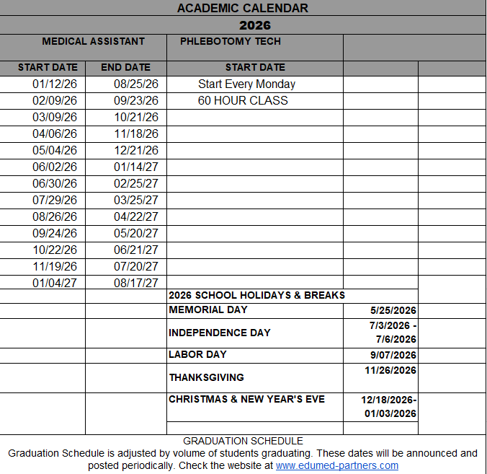


Kleber Molina, MD
Faculty & Staff
OWNER, CEO, Campus Director, DOE - Full Time
State University Cuenca (Ecuador)
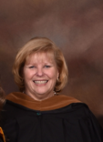
Sandra Overton, MT, MBA
OWNER, VP, CFO, - Full Time
Trevecca University (Nashville, TN)

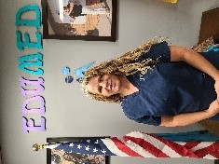
Nancy Matthews, Full Time Lead Instructor
Lead Instructor – Full Time
CCMA (EduMed Partners)


Tiffany Dragavon, A.A.S, CPhT, CAS, LXMO
Adjunct Instructor – As Needed
HTI/ NPTA (Houston)

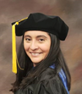
Paola Molina PhD Molecular Biology
Consultant
MTSU University

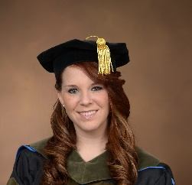
Kelli Binion, PhD Pharmacy
Consultant
East TN State University
Gatton School of Pharmacy


Chelsey Molina, M.S. Medicine
Consultant
Trevecca Nazarene University


Melissa Vale, B.S. HR Major
Part Time HR Business Partners
Tennessee Tech University


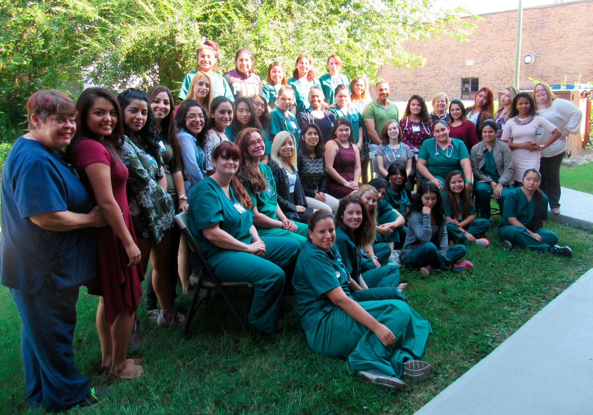

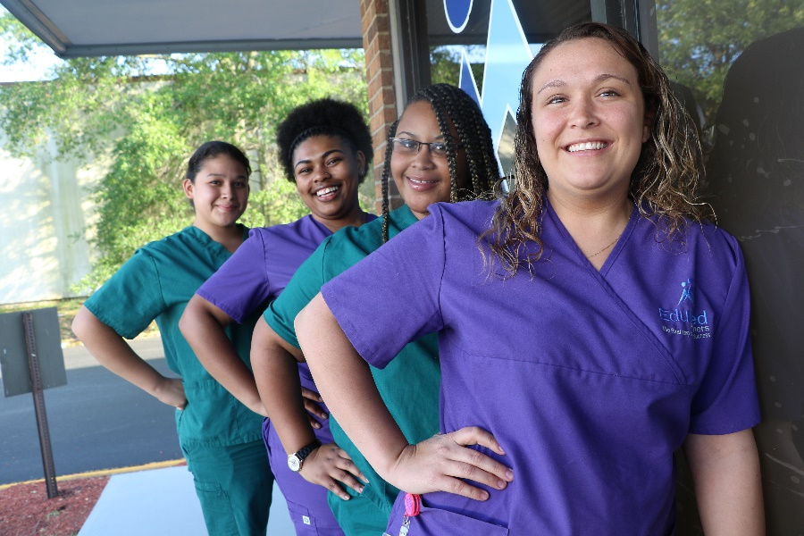

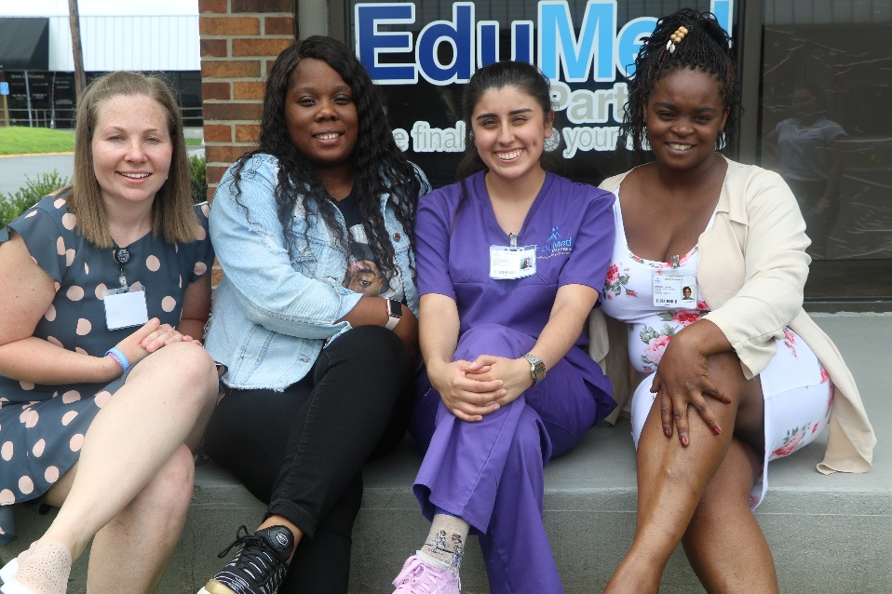

2026

